Thomas W. Corwin, DDS, FAGD, D. ABDSM
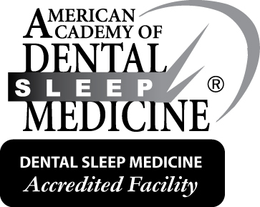
Dental Sleep Medicine
Diplomate of the American Board of Dental Sleep Medicine

Accredited by the American Academy of Dental Sleep Medicine

Snoring and Sleep Apnea Dental Treatment Center of Maine
650 Brighton Avenue, Portland, Maine 04102

Custom Oral Appliance Therapy for the Management of Sleep Apnea and Snoring

Tel: (207) 773-6331 Fax: (207) 773-3701 www.SleepApneaMaine.com
Please send a copy of the Diagnostic Sleep Study as well as relevant clinical notes for those patients with sleep apnea.
A diagnostic sleep study is not necessary if the diagnosis is Snoring (R06.83)

Treatment Orders (please check)

__ Custom Mandibular Advancement Appliance (E0486)
__ Other________________________________

Medical History: Check all that apply

- Excessive daytime sleepiness
- Mood disorder
- Hypertension
- History of stroke
- Impaired cognition
- Insomnia
- Ischemic heart disease/heart attack
Diagnosis (please check)

- G47.33 Obstructive sleep apnea (adult) (pediatric)
- R06.83 Snoring
- Other____________________________

Only G47.33 will be payable by insurance.
UARS should be under the G47.33 code.
Patient Name: ______________________________________________________DOB____________________
Address: __________________________________________________________________________________
City: _________________________________________ State: ______________ Zip code_________________
Phone: Home______________________ Work: ______________________ Cell:________________________
Email: ____________________________________________________________________________________
Insurance: Please send a photocopy of both sides of the patient’s medical insurance card.
It may also be necessary to send an Out of Network referral to the patient’s insurance company.

5
4
3
2
1

Ordering Physician’s name: _____________________________________________________
Phone: _________________________________ Fax: ________________________________
Due to the history and diagnosis above, I am recommending oral appliance therapy for the treatment of this patient. I, the undersigned, certify that the procedure prescribed above is reasonable and medically necessary for the treatment of this patient’s condition.

Ordering Physician’s Signature: ___________________________________________Date: _________________
Oral Appliance Referral Form – Please complete all five sections

Fax this completed form to Dr. Corwin at (207) 773-3701.
Please call (207) 773-6331 to schedule an appointment with Dr. Corwin.

